How to save your tree from Japanese Honeysuckle, Invasive Bittersweet and Asian Wisteria
(and from other invasive vines that wrap around or drape themselves over trees)
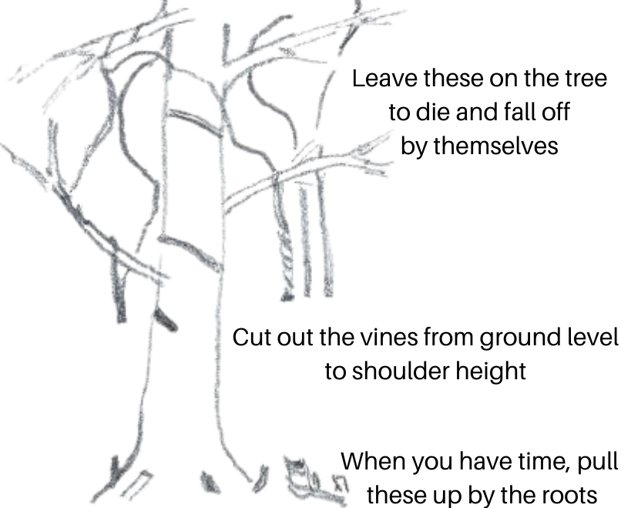
- Use garden clippers (or a saw for large vines) to cut the vines close to the ground.
- Cut them again around shoulder height and remove the vines in between. This makes it easy to see what you have done and keeps the vines from providing a ladder for new vines to grow up.
- Leave the rest of the vines on the tree. Trying to pull them off may hurt the tree and also could pull branches down onto your head.
- Congratulations - you have saved the tree! To keep the vines on the ground from growing back, pull them up by the roots.

Try not to accidentally cut any native vines, which don’t hurt the trees and which are an important food source for birds and other wildlife. Common examples are native grape vines, Greenbrier, and Trumpet Creeper For more information, see www.plantnovatrees.org/tree-rescuers-volunteer-program.

How to save your tree from Japanese Honeysuckle, Invasive Bittersweet and Asian Wisteria
(and from other invasive vines that wrap around or drape themselves over trees)
- Use garden clippers (or a saw for large vines) to cut the vines close to the ground.
- Cut them again around shoulder height and remove the vines in between. This makes it easy to see what you have done and keeps the vines from providing a ladder for new vines to grow up.
- Leave the rest of the vines on the tree. Trying to pull them off may hurt the tree and also could pull branches down onto your head.
- Congratulations - you have saved the tree! To keep the vines on the ground from growing back, pull them up by the roots.

Try not to accidentally cut any native vines, which don’t hurt the trees and which are an important food source for birds and other wildlife. Common examples are native grape vines, Greenbrier, and Trumpet Creeper For more information, see www.plantnovatrees.org/tree-rescuers-volunteer-program.

